Ideation Phase
Empathize & Discover

Date | 31 January 2025
Team ID | LTVIP2025TMID36086
Project Name | Enchanted Wings: Marvels of Butterfly Species
Maximum Marks | 4 Marks

Empathy Map Canvas:
An empathy map is a simple, easy-to-digest visual that captures knowledge about a user’s behaviours and attitudes.

It is a useful tool to helps teams better understand their users.
Creating an effective solution requires understanding the true problem and the person who is experiencing it. The exercise of creating the map helps participants consider things from the user’s perspective along with his or her goals and challenges.
Example:


Reference: https://www.mural.co/templates/empathy-map-canvas

🧠 Empathy Map Canvas
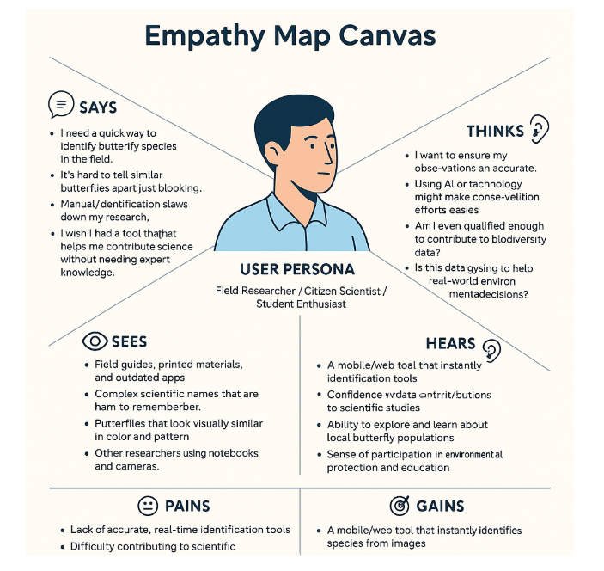
Understanding the user experience for biodiversity researchers and citizen scientists
🧍 User Persona:
Field Researcher / Citizen Scientist / Student Enthusiast

🗣️ SAYS
- "I need a quick way to identify butterfly species in the field."
- "It’s hard to tell similar butterflies apart just by looking."
- "Manual identification slows down my research."
- "I wish I had a tool that helps me contribute to science without needing expert knowledge."

💭 THINKS
- "I want to ensure my observations are accurate."
- "Using AI or technology might make conservation efforts easier."
- "Am I even qualified enough to contribute to biodiversity data?"
- "Is this data going to help real-world environmental decisions?"

👂 HEARS
- "You need to be an expert to tell butterfly species apart."
- "There’s an app for that, but it’s not very accurate."
- "Scientists use expensive equipment – I can’t afford that."
- "AI can misclassify things sometimes."

👀 SEES
- Field guides, printed materials, and outdated apps
- Complex scientific names that are hard to remember
- Butterflies that look visually similar in color and pattern
- Other researchers using notebooks and cameras

😔 PAINS
- Lack of accurate, real-time identification tools
- Difficulty contributing to scientific research without proper background
- Frustration from misclassification or slow manual search
- Feeling excluded from professional conservation efforts

🎯 GAINS
- A mobile/web tool that instantly identifies species from images
- Confidence in data contributions to scientific studies
- Ability to explore and learn about local butterfly populations
- Sense of participation in environmental protection and education

